**Project Development phase**

**Sprint-2**

**Design of web application using Node-Red**

Using Dashboard nodes for create UI(Web application):

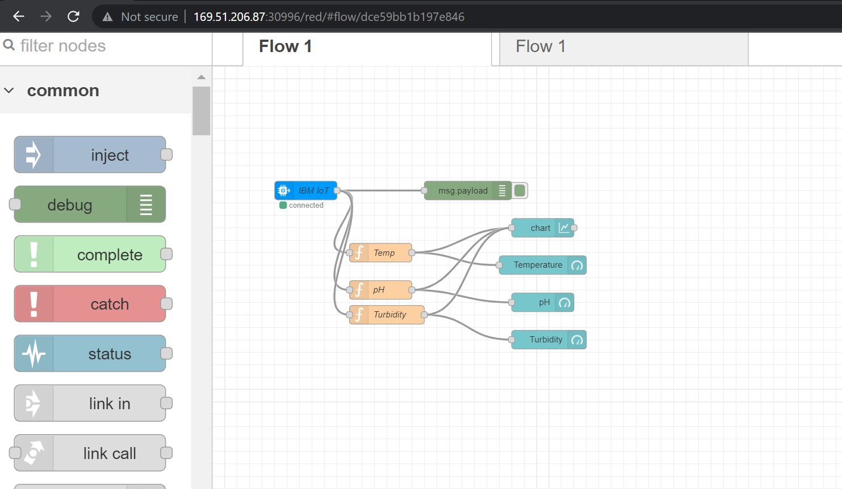

IBMIOT input node configuration:

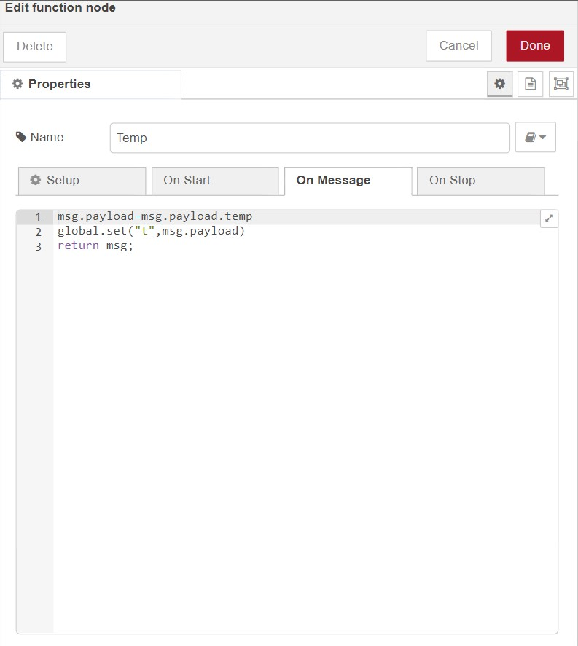

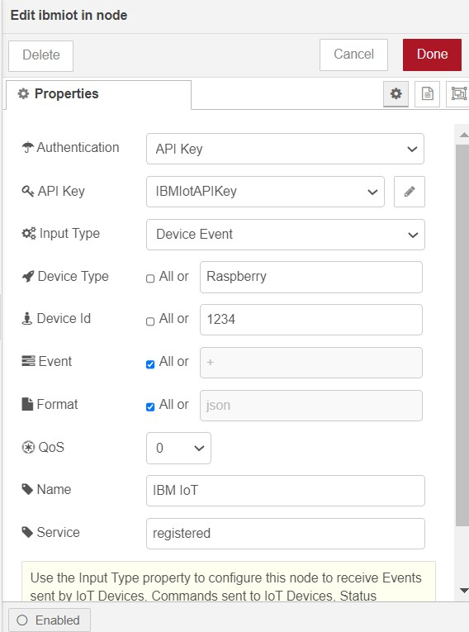

Debug Node output:

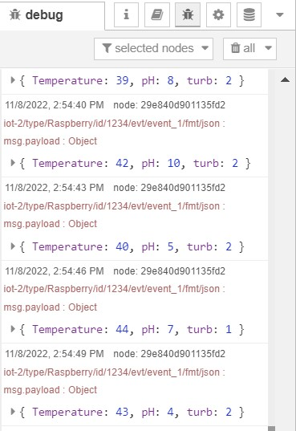

Temperature function node script:

IBM Watson IoT Platform (Sensor readings stored in cloud):

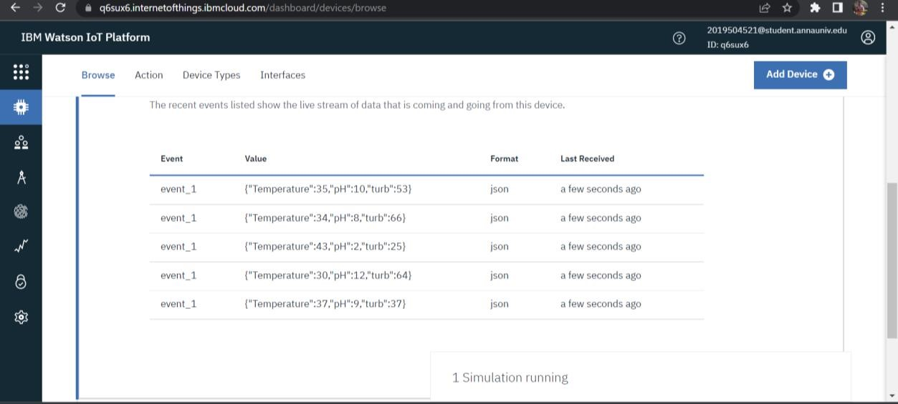

Web Application(User Interface):

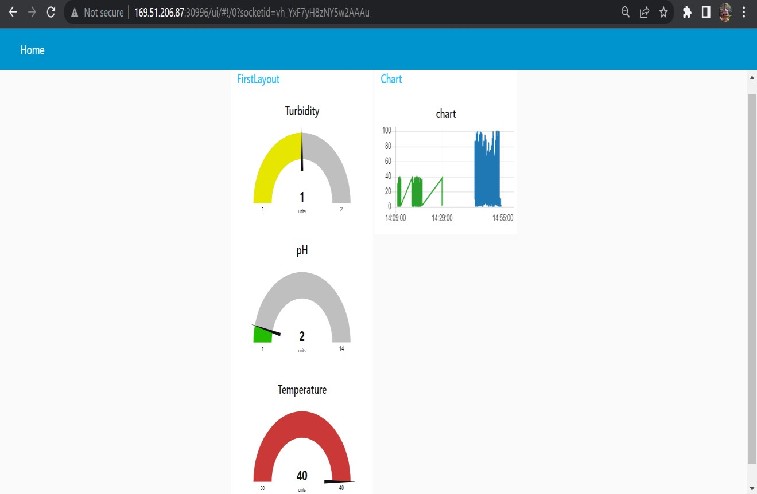

Web UI link: [http://169.51.206.87:30996/ui/#!/0?socketid=p-TNVtUhTDbqF2CAAAw](http://169.51.206.87:30996/ui/%23!/0?socketid=p-TNVt-UhTDbqF2CAAAw)